Unified Cross-country Annual Time-series of LCOE by Renewable Technology and Calculated Annual Average Day Ahead Electricity Price Dataset
Hasibul Hasan Ahmed
Introduction:
The global energy landscape has undergone a profound transformation over the past two decades, driven by rapid technological advancements, declining renewable energy costs, and increasing policy commitments toward decarbonization. To support rigorous analysis of these trends, this dataset compiles a comprehensive, multi-technology, multi-country view of renewable energy costs and electricity market prices from 2010 to 2023. It integrates publicly available data from the International Renewable Energy Agency (IRENA) and the Global Day-Ahead Electricity Price Dataset hosted on Mendeley Data, creating a unified resource for comparative cost assessment, trend analysis, and energy-economic modeling.
Renewable Energy LCOE Data (IRENA)
The dataset includes Levelized Cost of Electricity (LCOE) values for major renewable technologies, extracted and harmonized from IRENA’s Renewable Power Generation Costs in 2023 report and statistical databases. It covers both country-level and global weighted-average cost trajectories:
Country-Level LCOE
Onshore Wind (2010–2023)
LCOE data for 15 countries (Australia, China, France, Germany, India, UK, US, Italy, Japan, South Korea, Spain, Mexico, Turkey, Chile, Netherlands), enabling cross-country comparison of cost evolution in one of the most mature renewable technologies.
Utility‑Scale Solar PV (2018–2023)
LCOE data for 13 countries (Australia, China, France, Germany, India, UK, US, Italy, Japan, South Korea, Mexico, Chile, Netherlands), capturing the rapid cost decline and deployment acceleration of solar PV in recent years.
Global Weighted-Average LCOE
To contextualize country-level trends, the dataset also includes global weighted-average LCOE values for six renewable technologies:
- Offshore Wind (2010–2023)
- Concentrated Solar Power (CSP) (2010–2023)
- Hydropower (2010–2023)
- Geothermal (2010–2023)
- Bioenergy (2010–2023)
These global series provide long-term cost trajectories that reflect aggregated project-level data across multiple regions.
Electricity Market Price Data (Mendeley Data)
To complement the LCOE information, the dataset incorporates day-ahead electricity market prices for the same 15 countries included in the onshore wind LCOE subset. The raw hourly price data were sourced from the Global Day-Ahead Electricity Price Dataset (Mendeley Data) and processed to compute annual average electricity prices for each country from 2010 to 2023.
This integration enables direct comparison between:
- the cost of generating renewable electricity (LCOE), and
- the market value of electricity (day-ahead prices).
Such comparisons are essential for evaluating competitiveness, investment viability, trend analysis and policy impacts across different energy systems.
Methodology
This dataset was constructed through a two‑stage process involving data extraction, and aggregation from two primary sources: the International Renewable Energy Agency (IRENA) and the Global Day‑Ahead Electricity Price Dataset hosted on Mendeley Data. The methodology ensures consistency across technologies, countries, and time periods, enabling robust comparative and econometric analysis.
Data Acquisition
1.1 IRENA Renewable Energy Cost Data
LCOE data for renewable energy technologies were extracted from IRENA’s Renewable Power Generation Costs in 2023 report and statistical datasets. The following subsets were collected:
- Country-level LCOE
  - Onshore wind: 15 countries (2010–2023)
  - Utility-scale solar PV: 13 countries (2018–2023)
- Global weighted-average LCOE
  - Offshore wind: 2000–2023
  - Concentrated Solar Power (CSP): 2010–2023
  - Hydropower: 2010–2023
  - Geothermal: 2010–2023
  - Bioenergy: 2010–2023
Data were downloaded in .CSV formats for the given timeseries.
1.2 Mendeley Day-Ahead Electricity Price Data
Hourly electricity market prices were obtained from the Global Day-Ahead Electricity Price Dataset on Mendeley Data. The dataset includes raw market prices for multiple countries and bidding zones.
For consistency with the onshore wind LCOE subset, the same 15 countries were selected.
Data Pre-Processing
2.1 Standardization of Units and Formats
- All LCOE values have consistent unit: USD/kWh as of 2023.
- Electricity prices were standardized to annual average prices in USD/kWh.
- Inflation adjustments were only applied to market that primarily uses USD using following calculator (https://www.in2013dollars.com/) or unless already included in the source data.
- All the market prices were converted to USD/kWh as of 2023 using https://www.exchangerates.org.uk/ which was primarily in own market currency as following Figure 1:
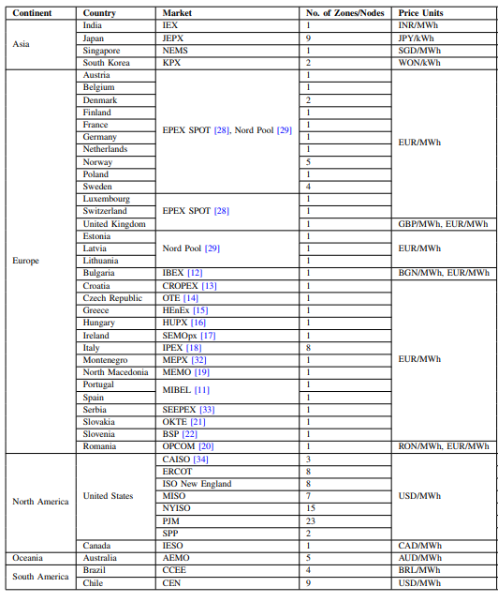
Figure 1: Electricity Price Dataset Information by Mendeley| Ullah et al. 2025
2.2 Handling Missing Values
- Years with missing LCOE values were left blank to preserve data integrity.
- Countries with incomplete solar PV data (pre-2018) were retained without interpolation.
2.3 Country Matching and Harmonization
Country names and codes were standardized across both datasets to ensure:
- consistent merging
- compatibility with modeling tools
- reproducibility

Data Transformation
3.1 Annual Average Electricity Price Calculation
For each country:
Raw hourly prices were directly aggregated including multiple bidding zones to simply form a simple average was used to calculate annual average electricity prices.
Calculation method:
A python-base code snippet was prepared to handle datafiles manually to calculate the average price. Source Code: https://github.com/Hasib9025/Subsidy-Proxy---LCOE-of-Renewables-Annual-Average-Electricity-Price-2010-2023-for-15-Countries-/blob/main/Day_Ahead_Price_Avrg_Calc_USA.ipynb

Sources:
- IRENA-Datafile-RenPwrGenCosts-in-2023-v1: https://irena.sharepoint.com/:x:/s/statistics-public/EadRMwuKf9RKuyr5aMiulQ0BW-yR_gSPJ--YgRa15kNeRg?e=m27gCS
- Detailed report by IRENA: https://www.irena.org/Publications/2024/Sep/Renewable-Power-Generation-Costs-in-2023
- Global Day-Ahead Electricity Price Dataset : https://data.mendeley.com/datasets/s54n4tyyz4/3
- Detailed report on Global Day-Ahead Electricity Price Dataset: M. H. Ullah, S. M. Reza, L. M. Gundapaneni, P. Balachander, B. Babaiahgari and A. A. A. Khan, "Descriptor: Unified Cross-Regional Time-Series Day-Ahead Electricity Price Dataset (UniElecPrice)," in IEEE Data Descriptions, vol. 2, pp. 329-339, 2025, doi: 10.1109/IEEEDATA.2025.3609683. Source: https://ieeexplore.ieee.org/document/11169754

